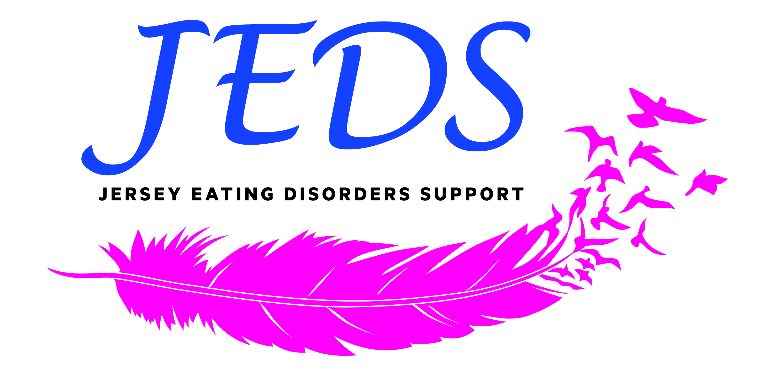
JEDS
AMBASSADOR INTRODUCTION FORM
Help us introduce you to the JEDS community 💗💙
Thank you for becoming a JEDS Ambassador! We would love to introduce you to our supporters and the wider Jersey community through our social media.
Please answer the questions below in as much or as little detail as you feel comfortable with. You do not have to answer any question you would prefer not to. Your answers may be edited slightly for length, spelling or clarity before publication.
1. ABOUT YOU
Name:
What would you like us to call you publicly? (if different):
Tell us a little bit about yourself:

2. YOUR JEDS AMBASSADOR ROLE
1. What made you want to become a JEDS Ambassador?

2. Why do you think the work JEDS does is important?

4. What is one thing you wish more people understood about eating disorders?

5. Why do you think raising awareness of eating disorders is important?

6. What are you hoping to achieve through being a JEDS Ambassador?

7. What do you do, or plan to do, to support the charity as JEDS Ambassador?

3. A MESSAGE TO OTHERS
What would you say to someone affected by an eating disorder who might be struggling to reach out for support?

4. A FEW FUN FACTS
What are three words that describe you?

What is your favourite place in Jersey?

What is your favourite food?

Coffee or tea?

Early bird or night owl?

What is something that always makes you smile?

What is one thing on your bucket list?

5. SOCIAL MEDIA & PHOTO PERMISSION
Please tick the boxes below to confirm what you are happy for JEDS to use in connection with your Ambassador introduction and future Ambassador content.
☐ I am happy for JEDS to publish my name and the information I have provided in this form on its social media and website.
☐ I am happy for JEDS to use a photograph of me for my Ambassador introduction and related JEDS communications.
☐ I understand that JEDS may lightly edit my answers for spelling, grammar, length or clarity while keeping the meaning of my answers.
☐ I understand that I can contact JEDS if I later wish to discuss or change how my information or photograph is used.
Anything you would prefer us NOT to share publicly:
6. SIGN-OFF
Name: | Date:
Signature:
Thank you for helping JEDS raise awareness, challenge stigma and let people know that support is available. 💗💙

